June 2, 2024 ~ 8:30 am
CONNECT WITH GOD: God knows you and wants you to know Him as God and Savior to receive from Him support, guidance, and peace in this life and assurance of an amazing new life after death. All are welcome here. Sunday services are that place where we come to gather and receive direction and grace. We never want to do things within our services just for the sake of doing them. We will do our best to align with Jesus’ invitation to worship in “spirit and in truth”.
CONNECT WITH FELLOW BELIEVERS: As part of our core identity, Redeemer by the Sea is a smaller gathering of people where we are thrilled to be able to get to know each other and care for each other. You will not be able to get “lost in the crowd” here. There are many opportunities to grow spiritually and serve others within the church and we are continually seeking ways to offer effective service to our community and world. If you’re ready to know more about these opportunities, contact Kay Boland, in the church office, 760-431-8990 x105, or by email at kay@redeemerbythesea.org.

PRELUDE “ Prelude on Eventide” by Franklin D. Ashdown

Welcome & announcements
Opening Hymn “Joyful, Joyful We Adore Thee" LSB 803
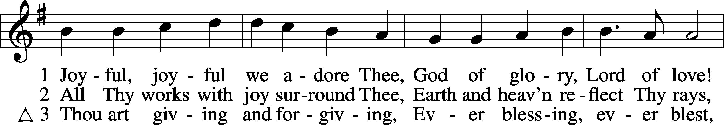
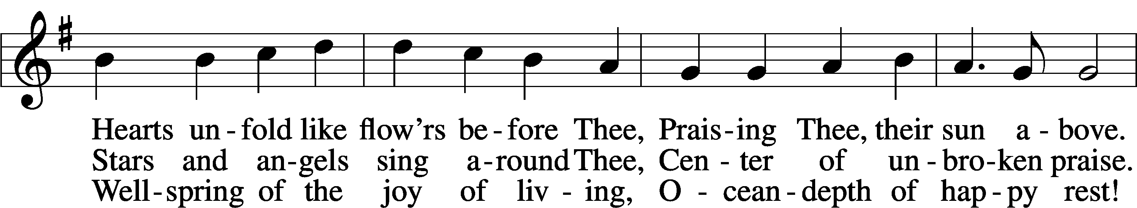
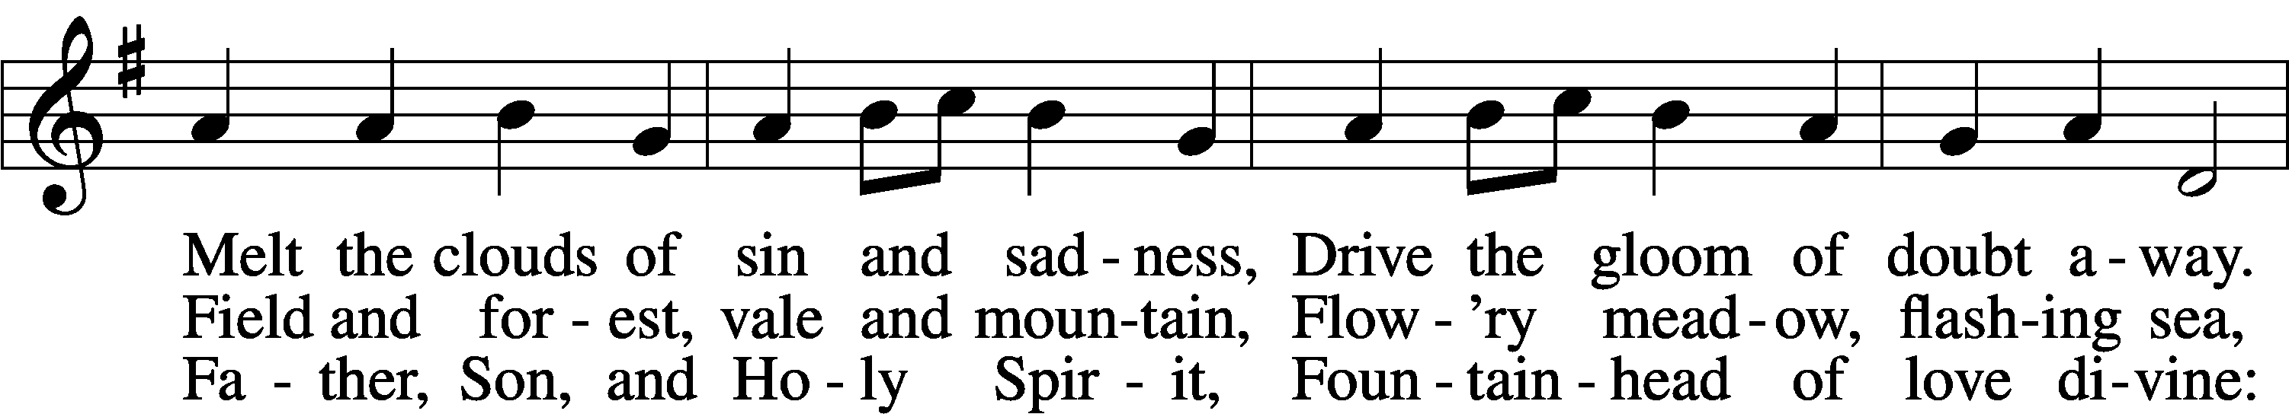
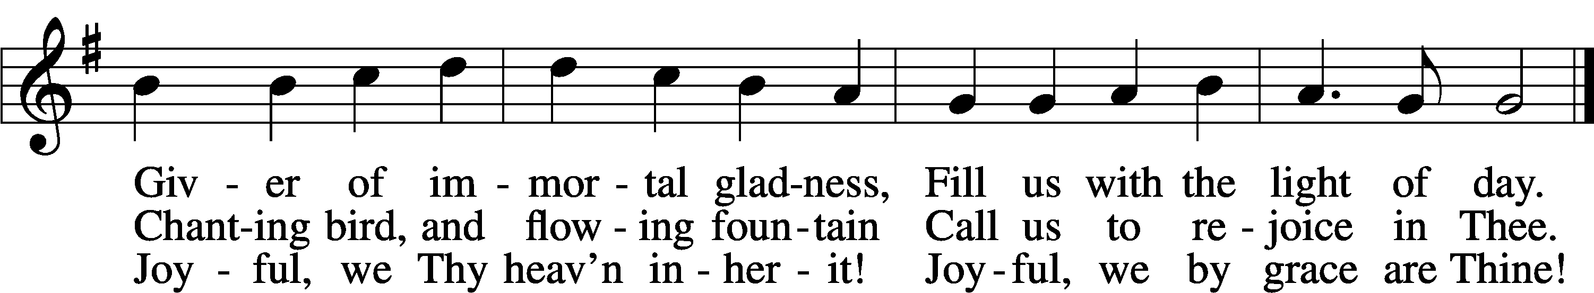
Text: Henry Van Dyke, 1852–1933, alt. Tune: Ludwig van Beethoven, 1770–1827; adapt. Edward Hodges, 1796–1867 Text and tune: Public domain

Invocation
Pastor: In the name of the Father and of the X Son and of the Holy Spirit.
People: Amen.

Confession and Absolution
Pastor: If we say we have no sin, we deceive ourselves, and the truth is not in us.
People: But if we confess our sins, God, who is faithful and just, will forgive our sins and cleanse us from all unrighteousness.
(silence for further personal reflection and specific confession)

Pastor: Let us then confess our sins to God our Father.
People: Most merciful God, we confess that we are by nature sinful and unclean. We have sinned against You in thought, word, and deed, by what we have done and by what we have left undone. We have not loved You with our whole heart; we have not loved our neighbors as ourselves. We justly deserve Your present and eternal punishment. For the sake of Your Son, Jesus Christ, have mercy on us. Forgive us, renew us, and lead us, so that we may delight in Your will and walk in Your ways to the glory of Your holy name. Amen
Pastor: God has heard our prayer, and has sent His Son into our world, to die for us and to rise again that we may have new life. As a called and ordained servant of the word, and at the command of my Lord Jesus Christ, I announce the grace of God unto all you, your sins are forgiven, in the name of the Father and of the Son X and of the Holy Spirit.
People: Amen.

Kyrie
Pastor: In peace let us pray to the Lord.
People: Lord, have mercy.
Pastor: For the peace from above and for our salvation let us pray to the Lord.
People: Lord, have mercy.
Pastor: For the peace of the whole world, for the well-being of the Church of God, and for the unity of all let us pray to the Lord.
People: Lord, have mercy.
Pastor: For this holy house and for all who offer here their worship and praise, let us pray to the Lord.
People: Lord, have mercy.
Pastor: Help, save, comfort, and defend us, gracious Lord.
People: Amen.

Hymn of Praise “This is the Feast" LSB 155
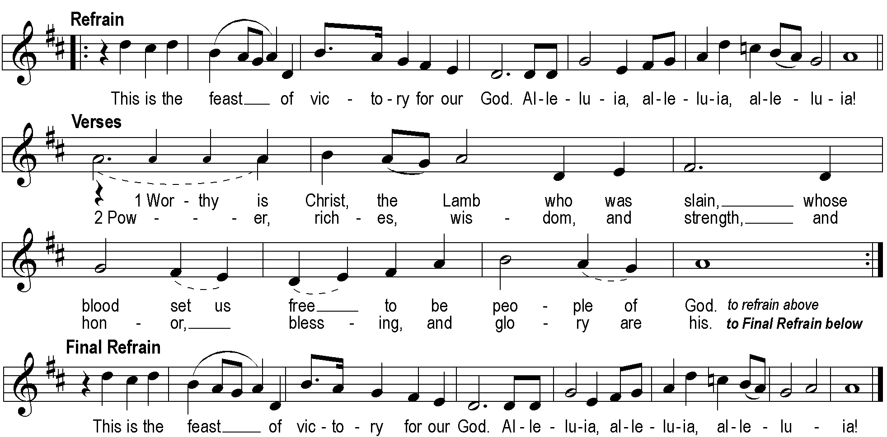

collect of the day
All: Eternal God, Your Son Jesus Christ is our true Sabbath rest. Help us to keep each day holy by receiving His Word of comfort that we may find our rest in Him, who lives and reigns with You and the Holy Spirit, one God, now and forever.

Sharing God’s peace

The first Reading Psalm 8 (ESV)
O Lord, our Lord, how majestic is your name in all the earth! You have set your glory above the heavens. ² Out of the mouth of babies and infants, you have established strength because of your foes, to still the enemy and the avenger. ³ When I look at your heavens, the work of your fingers, the moon and the stars, which you have set in place, ⁴ what is man that you are mindful of him, and the son of man that you care for him? ⁵ Yet you have made him a little lower than the heavenly beings and crowned him with glory and honor. ⁶ You have given him dominion over the works of your hands; you have put all things under his feet,
⁷ all sheep and oxen, and also the beasts of the field, ⁸ the birds of the heavens, and the fish of the sea, whatever passes along the paths of the seas. ⁹ O Lord, our Lord, how majestic is your name in all the earth!
Reader: This is the word of the Lord.
All: Thanks be to God.
The second Reading Hebrews 2:5-8 (ESV)
For it was not to angels that God subjected the world to come, of which we are speaking. ⁶ It has been testified somewhere, “What is man, that you are mindful of him, or the son of man, that you care for him? ⁷ You made him for a little while lower than the angels; you have crowned him with glory and honor, ⁸ putting everything in subjection under his feet.” Now in putting everything in subjection to him, he left nothing outside his control. At present, we do not yet see everything in subjection to him.
Reader: This is the word of the Lord.
All: Thanks be to God.

Alleluia and verse LSB 173
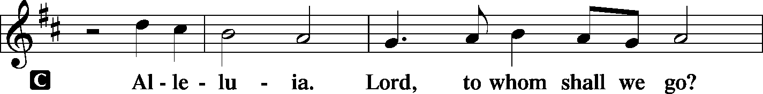
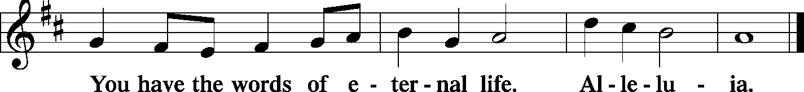

Holy Gospel Matthew 10:29-31 (ESV)
Pastor: The Gospel reading today comes from Matthew chapter 10.
People: Glory to you, O Lord.
²⁹ Are not two sparrows sold for a penny? And not one of them will fall to the ground apart from your Father. ³⁰ But even the hairs of your head are all numbered. ³¹ Fear not, therefore; you are of more value than many sparrows.
Pastor: This is the Gospel of the Lord.
People: Praise to you, O Christ.

NICENE CREED
I believe in one God, the Father Almighty, maker of heaven and earth and of all things visible and invisible.
And in one Lord Jesus Christ the only-begotten Son of God, begotten of his Father before all worlds, God of God, Light of Light, very God of very God, begotten, not made, being of one substance with the Father, by whom all things were made; who for us men and for our salvation came down from heaven and was incarnate by the Holy Spirit of the virgin Mary and was made man; and was crucified also for us under Pontius Pilate. He suffered and was buried. And the third day he rose again according to the Scriptures and ascended into heaven and sits at the right hand of the Father. And he will come again with glory to judge both the living and the dead, whose kingdom will have no end.
And I believe in the Holy Spirit, the Lord and giver of life, who proceeds from the Father and the Son, who with the Father and the Son together is worshiped and glorified, who spoke by the prophets. And I believe in one holy Christian and apostolic Church, I acknowledge one Baptism for the remission of sins, and I look for the resurrection of the dead and the life of the world to come. Amen.

hymn of praise “O Christ, Who Called the Twelve" LSB 856

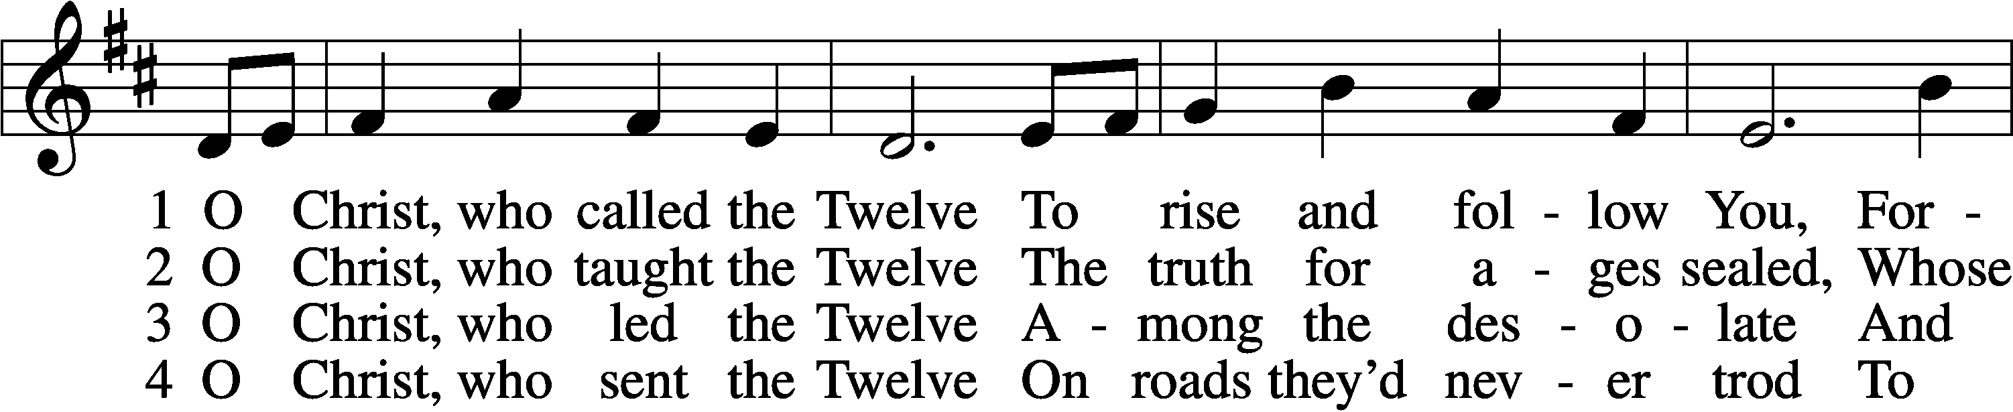

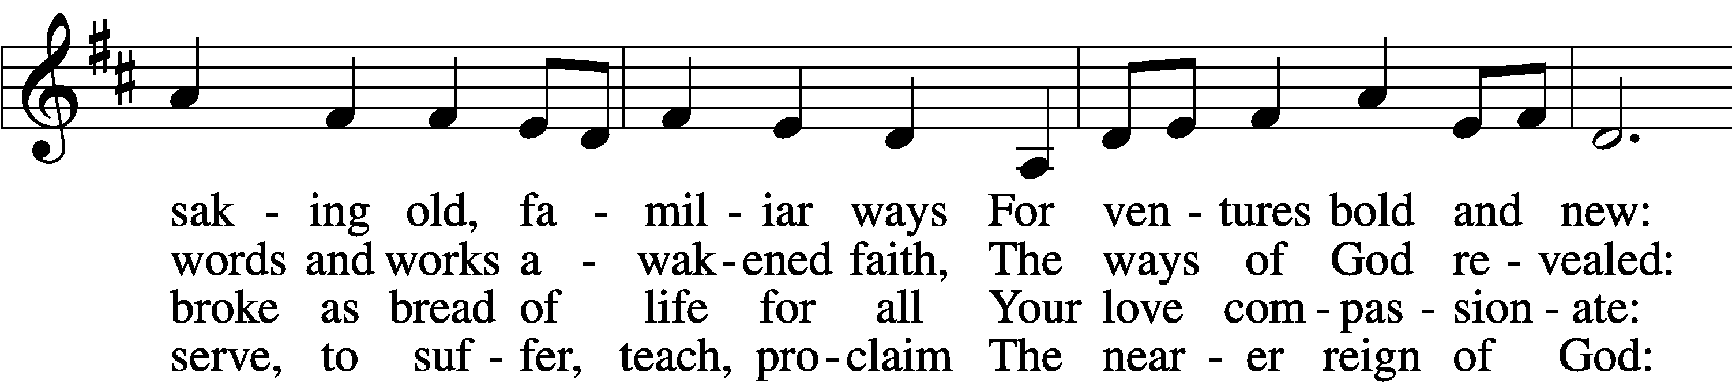

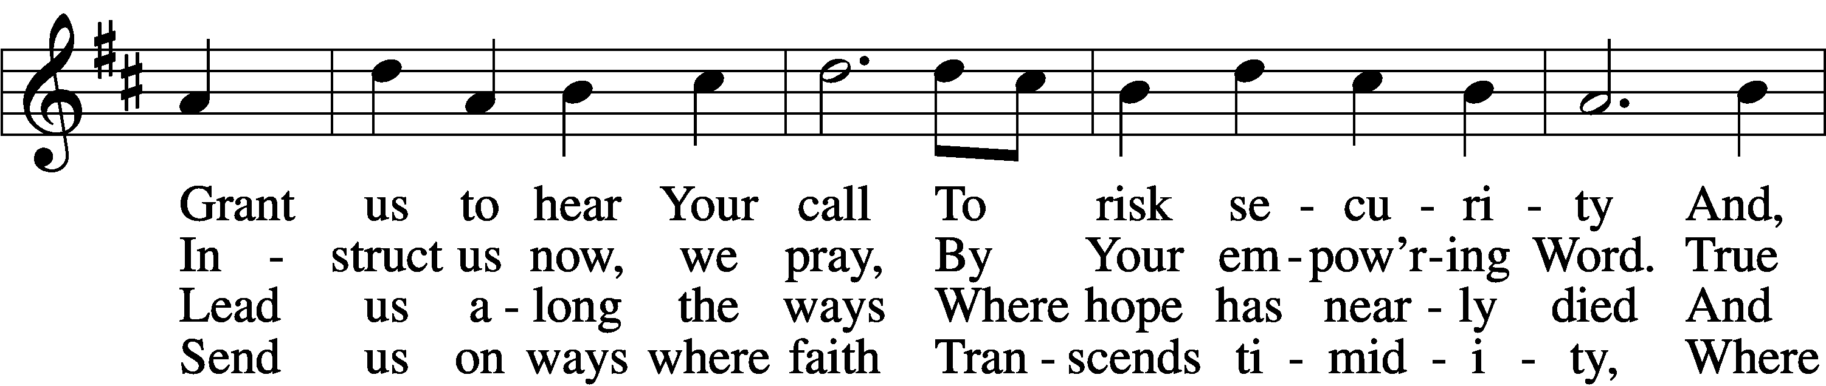

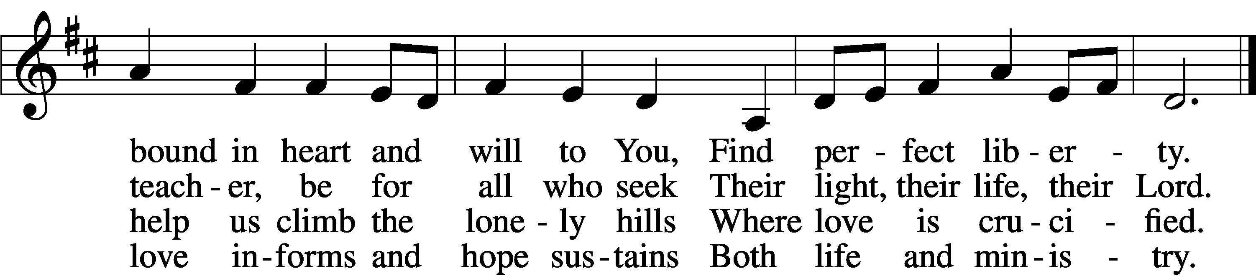

Text: Herman G. Stuempfle, Jr., 1923–2007 Tune: English; adapt. Franklin L. Sheppard, 1852–1930 Text: © 1993 GIA Publications, Inc. Used by permission: LSB Hymn License no. 110016216 Tune: Public domain

Message “Value" Pastor D. R. Hilken

song of response “How Great Thou Art-It Is Well-Great is Thy Faithfulness” Video

Prayers of the church
Pastor: (concluding each petition) Lord, in Your mercy:
People: hear our prayer.

LORD’S PRAYER
Our Father, who art in heaven, hallowed be Thy name. Thy kingdom come. Thy will be done on earth, as it is in heaven. Give us this day our daily bread, and forgive us our trespasses, as we forgive those who trespass against us. And lead us not into temptation; but deliver us from evil; For thin is the kingdom and the power, and the glory, forever and ever. Amen.

+ SERVICE OF THE SACRAMENT +

PREFACE
Pastor: The Lord be with you
People: And also with you.
Pastor: Lift up your hearts.
People: We lift them to the Lord.
Pastor: Let us give thanks to the Lord our God.
People: It is right for us to do so.
Pastor: It is our joy and our peace, at all times and in all places to give thanks to you, Holy Father, almighty and everlasting God through Jesus Christ, our Lord. We especially thank You for sending your Son, Jesus Christ, into the world to bear our sins on the cross, and to carry the burdens of our broken humanity. We look in faith for forgiveness, joy and healing, and in expectation of the fulfillment of your kingdom’s presence we join the unending praise of the hosts of heaven and say:

SANCTUS LSB 161
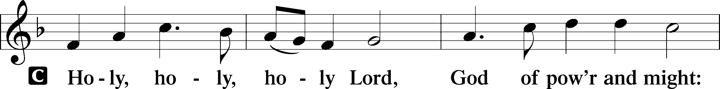
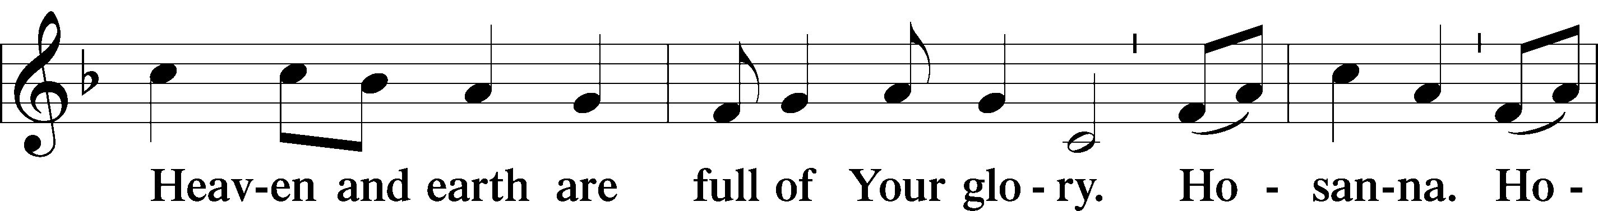
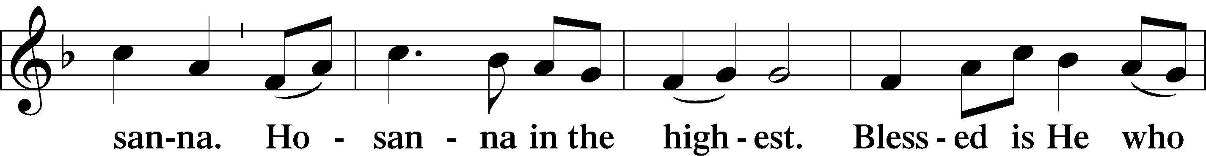
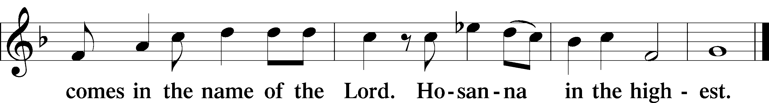
Pastor: Blessed are You, Lord of heaven and earth, for You have had mercy on those whom You created and sent Your only-begotten Son into our flesh to bear our sin and be our Savior. With repentant joy we receive the salvation accomplished for us by the sacrifice of His body and His blood on the cross.
Gathered in the name and the remembrance of Jesus, we beg You, Lord to forgive, renew, and strengthen us with Your Word and Spirit. May we faithfully eat and drink as Jesus commands until that day when all the faithful will be gathered in the new kingdom to celebrate the marriage feast of the Lamb.
To You alone, Three in One, be all glory, honor, and worship, now and forever.
People: Amen.

Words of Institution
Pastor: As God's Word proclaims, as often as we eat this bread and drink this cup, we proclaim the Lord's death, His rest in the tomb, His resurrection from the dead, His ascension into heaven, and His return for the final judgment.
People: Amen. Come, Lord Jesus.
DISTRIBUTION

Post-Communion Hymn “I Come, O Savior, to Thy Table” LSB 618
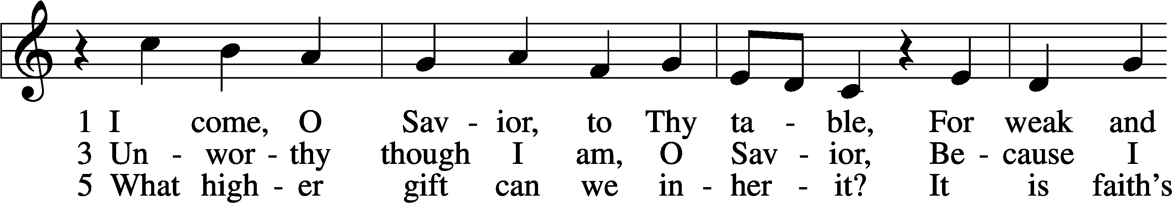
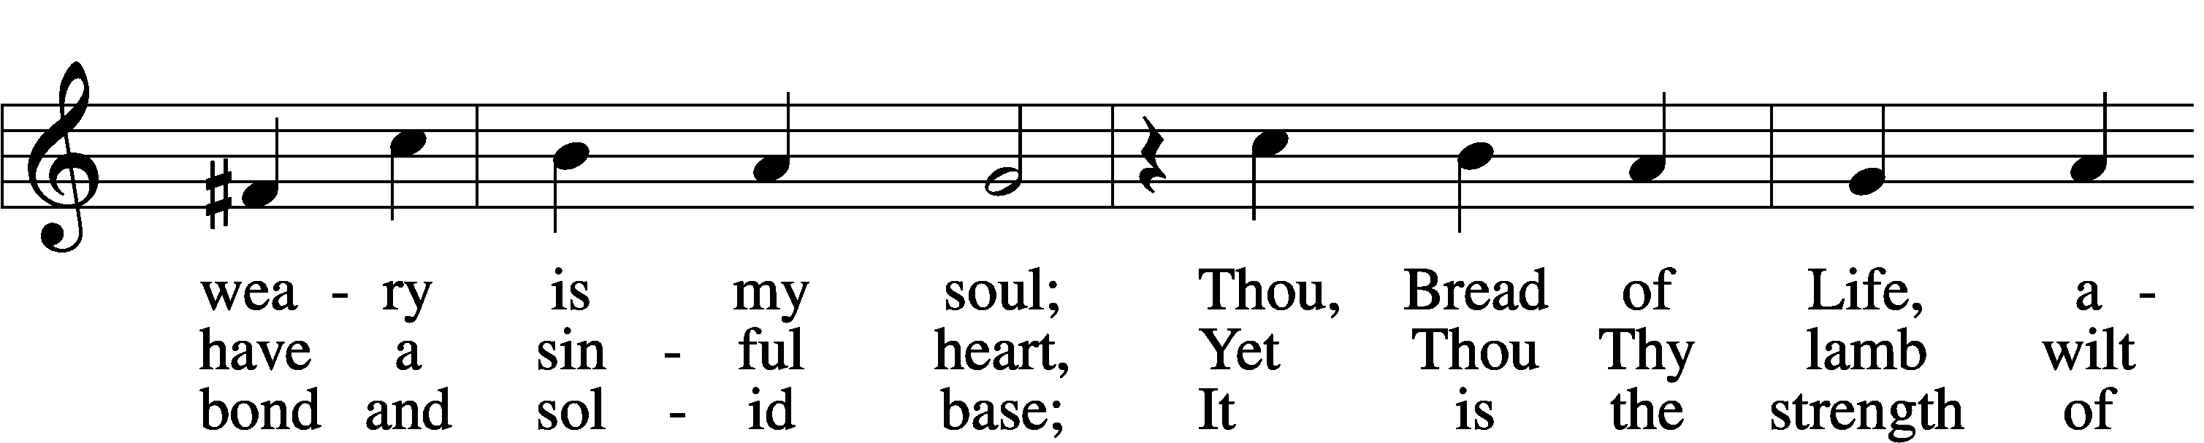
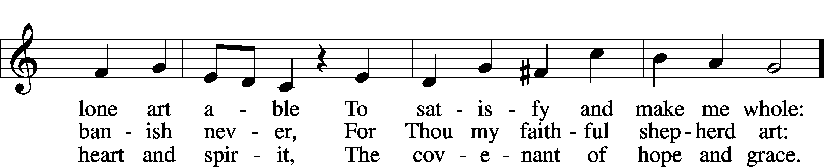
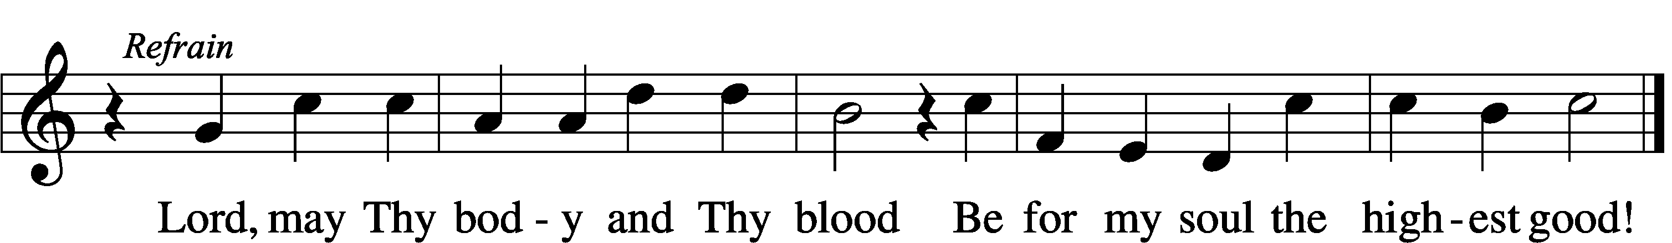
Text: Friedrich Christian Heyder, 1677–1754; tr. The Lutheran Hymnal, 1941, abr. Tune: Emskirchner Choral-Buch, 1756, Leipzig Text: © 1941 Concordia Publishing House. Used by permission: LSB Hymn License no. 110016216 Tune: Public domain

Post-Communion collect
Pastor: We give thanks to You, almighty God, that You have refreshed us through this salutary gift, and we implore You that of Your mercy You would strengthen us through the same in faith toward You and in fervent love toward one another; through Jesus Christ, Your Son, our Lord, who lives and reigns with You and the Holy Spirit, one God, now and forever.
People: Amen.

benediction
Pastor: The Lord bless you and keep you. The Lord make his face shine on you and be gracious to you. The Lord look upon you with favor and X give you peace.
People: Amen.
Closing hymn “Jesus Shall Reign” LSB 832
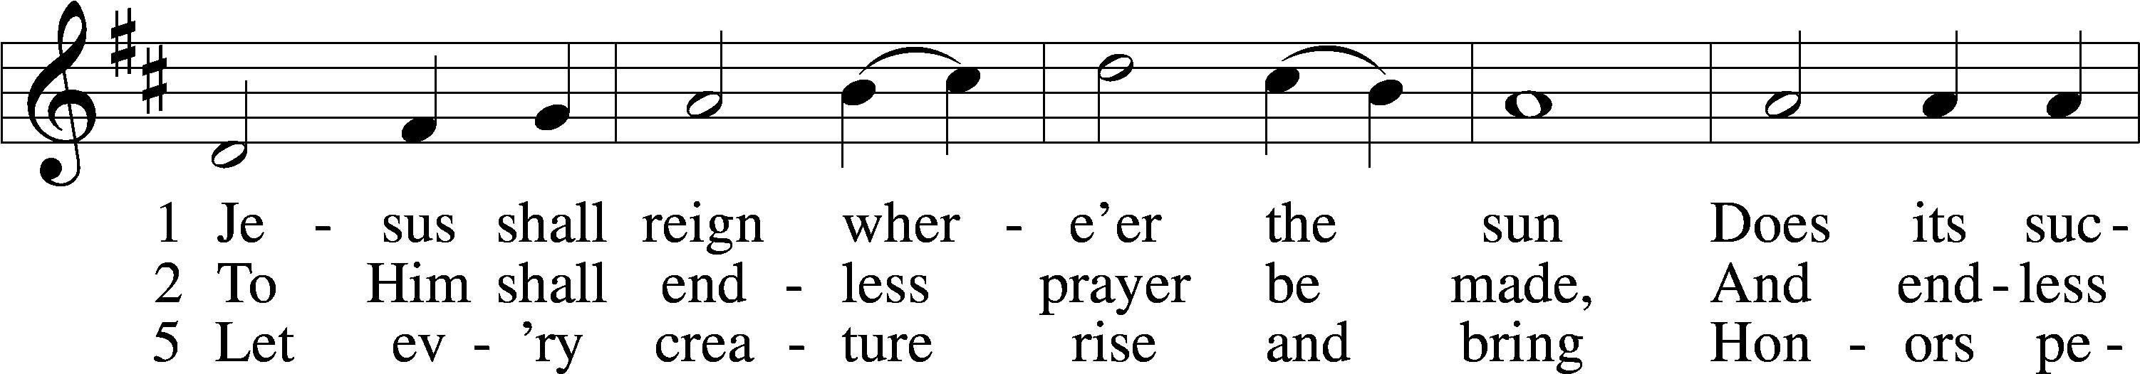
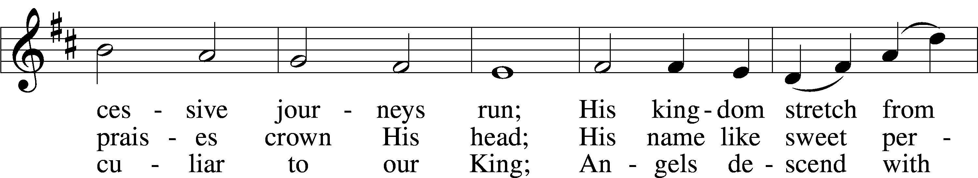
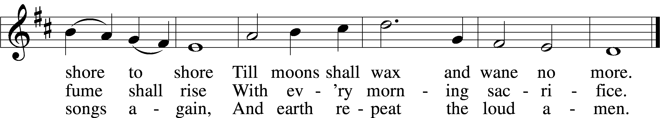
Text: Isaac Watts, 1674–1748, alt. Tune: attr. John C. Hatton, d. 1793 Text and tune: Public domain

Sending
Pastor: Go in peace and serve the Lord.
People: Thanks be to God!
POSTLUDE “Partita on St. Denio” by Franklin D. Ashdown

Acknowledgments - Divine Service, Setting Two from Lutheran Service Book. Unless otherwise indicated, all scripture quotations are from ESV. UBP. ARR. Created by Lutheran Service Builder © 2006 CPH

WORSHIP | GROW | SERVE
OFFERINGS: Visitors: please consider yourselves our guests and do not feel obligated to participate in the offering. In faithful obedience and joyful response to God’s grace in our lives, we humbly and gratefully bring our tithes (a regular first portion percentage of our income) and offerings (gifts over and above our tithes for other kingdom work). You may deposit your envelope, check, or cash in the box next to the exit; give online with your phone using the QR code at right or text "GIVE' to 442-222-2448. All these options are on our website: www.redeemerbythesea.org/donate/
2024 GRADUATES – WE WOULD LIKE TO CELEBRATE WITH YOU! Parents of students graduating high school or college this year, please email a digital picture and information on degree/certification, the institution and future plans to Kay@redeemerbythesea by Mon. June 3rd. Then join us in church on June 9th when we will recognize graduates.
THE LIFE OF JESUS: A chronological study of Jesus in the Gospels. This Bible Study, led by Pastor D, will begin on Tues., June 4th at 4:30pm or Wed. June 5th at 9:30am in the Fellowship Hall. You are welcome to join in.
HOLY HACKERS: Our golf group will meet at St. Mark’s Executive Course in San Marcos next Sat., June 8th. We play best ball, so all skill levels are welcome to join. Email Rhonda if you’d like to play: missrhonda@redeemerbythesea.org.
LWM HAWAIIAN LUNCHEON: All women are invited to attend a Hawaiian Luncheon on Tues. June 11th at 11:30am in the Fellowship Hall. Invite a friend, show off your Hawaiian attire and come enjoy the day. There will be raffles ($1/ticket or $5/6 tickets), gifts and fellowship Please email your RSVP to bjclahr@cox.net by Mon. June 3rd. Aloha!
HAVE YOU REGISTERED YOUR CHILD FOR SCUBA VBS YET? Get your kids off those screens and into SCUBA VBS June 24-28 from 9am-noon at Redeemer by the Sea. Kids (ages 4-9) will dive into friendship with God and discover how to shine Jesus’ love and hope in everyday life! Activities include catchy songs, teamwork building games, yummy treats, one-of-a-kind Bible Adventures and Sciency-Fun experiments that get imagination bubbling. Cost is $150. All registrations are non-refundable. Register online at www.redeemerbythesea.org.
VBS SERVE TEAM 2024 REMINDER - Mandatory Staff Training on Wed. June 12th at 5:30pm in the Fellowship Hall.
CONGREGATIONAL VOTER’S MEETING: The next meeting will be on Sun. June 23rd at 11:30am (or immediately following worship). Please plan to attend and stay informed about what’s happening at Redeemer by the Sea!
VBS Decorating Day is Sun. June 23rd at noon (immediately following the Voter’s Meeting). Lunch will be provided with RSVP to missrhonda@redeemerbythesea.org prior to getting started. All are welcome as it takes many hands to transform the church for our underwater SCUBA adventure!
LIFELINE SCREENING will be at Redeemer by the Sea on Thurs. June 13th. A package of five screenings to identify risk for stroke, heart disease and other chronic conditions will be offered. Register by calling toll free 1-888-653-6441, online at https://llsa.social/HSC, or text the word "circle" to 797979. The church has one coupon for a complimentary screening to give away. Email Kerry@redeemerbythesea.org if interested.
PORTALS OF PRAYER for July – September 2024 are available to pick up in the lobby.
WELCOME DR. JOHN NAPLES as our guest organist today.

UPCOMING EVENTS:
www.RedeemerbytheSea.org
June 4 4:30pm The Life of Jesus Bible Study
June 5th 9:30am The Life of Jesus Bible Study
June 11th 11:30am LWM Hawaiian Luncheon
June 12th 5:30pm VBS Staff Training
June 23rd 11:30am Voter’s Meeting
June 23rd 12:00pm Decorating for VBS
June 24-28th 9am-noon SCUBA VBS

